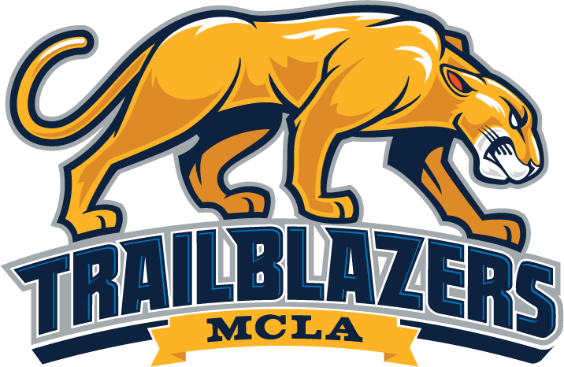

MCLA CAREER SERVICES SPRING 2023 CALENDAR

- Tuesday, February 7: Career Preparation Workshop (first-year students only)
Time: 2:00-3:00 Location: Career Center (Bowman Hall 217)
Freshmen only workshop. It will cover all aspects of career preparation, including the ONET* Interest Profiler, Handshake, resume/cover letter preparation, successful interviewing tips and techniques, job shadowing, and internships.

- Tuesday, February 14: Career Preparation Workshop
Time: 2:00-3:00 Location: Career Center (Bowman Hall 217)
This workshop will cover all aspects of career preparation, including the ONET* Interest Profiler, Handshake, resume/cover letter preparation, successful interviewing tips/techniques, job shadowing, and internships.

- Tuesday, February 21: Resume/Cover Letter Workshop
Time: 2:00-3:00 Location: Career Center (Bowman Hall 217)
This workshop will focus on how to build an effective resume and cover letter. Helpful tips will be provided, and sample resumes and cover letters will be reviewed.

- Tuesday, February 28: Interviewing Skills Workshop
Time: 2:00-3:00 Location: Career Center (Bowman Hall 217)
This workshop will cover important information required for a successful job interview experience. Topics will include proper etiquette and attire, telephone interviewing skills, virtual interviewing skills, and sample questions.

- Tuesday, March 14: Interviewing Skills Workshop
Time: 2:00-3:00 Location: Career Center (Bowman Hall 217)
This workshop will cover important information required for a successful job interview experience. Topics will include proper etiquette and attire, telephone interviewing skills, virtual interviewing skills, and sample questions.

- Thursday, March 16: Virtual Career & Internship Fair Informational Workshop
Time: 2:00-3:00 Location: Career Center (Bowman Hall 217)
This workshop will focus on how to be adequately prepared to participate in the MCLA Spring 2021 Virtual Career and Internship Fair. Topics will include Handshake career fair sign-ups for individual and group sessions with employers, Handshake profiles, career fair attire and etiquette, resume preparation, developing an effective “elevator pitch”, questions to ask employers, preparation for questions employers may ask students.

- Thursday, March 23: MCLA Virtual Career & Internship Fair
Time: 11:00-2:00 Location: Virtual
The spring 2022 MCLA Career & Internship Fair, sponsored through Handshake, is a tremendous opportunity to connect and network with employers and recruiters, both locally and nationally. 49 employers/recruiters and 50 students participated in this event last fall. Take full advantage of employment and internship opportunities by participating in the spring 2022 fair!

- Tuesday, April 11: Resume/Cover Letter Workshop
Time: 2:00-3:00 Location: Career Center (Bowman Hall 217)
This workshop will focus on how to build an effective resume and cover letter. Helpful tips will be provided, and sample resumes and cover letters will be reviewed.

